# Project Development Phase Model Performance Test

|  |  |
| --- | --- |
| Date | 20 July 2025 |
| Team ID | LTVIP2025TMID20285 |
| Project Name | TrafficTelligence – Traffic Volume Estimation Using Deep Learning |
| Maximum Marks | 10 Marks |

Model Performance Testing:  
Project team shall fill the following information in model performance testing template.

|  |  |  |
| --- | --- | --- |
| S.No. | Parameter | Values |
| 1 | Metrics | Regression Model: MAE: 42.7 RMSE: 59.3 R² Score: 0.84  Classification Model: Accuracy: ~85% Confusion Matrix Confidence Score |
| 2 | Tune the Model | Hyperparameter Tuning via GridSearchCV Validation Split: 20% Early Stopping / Cross Validation applied |

Screenshot - Confusion Matrix:

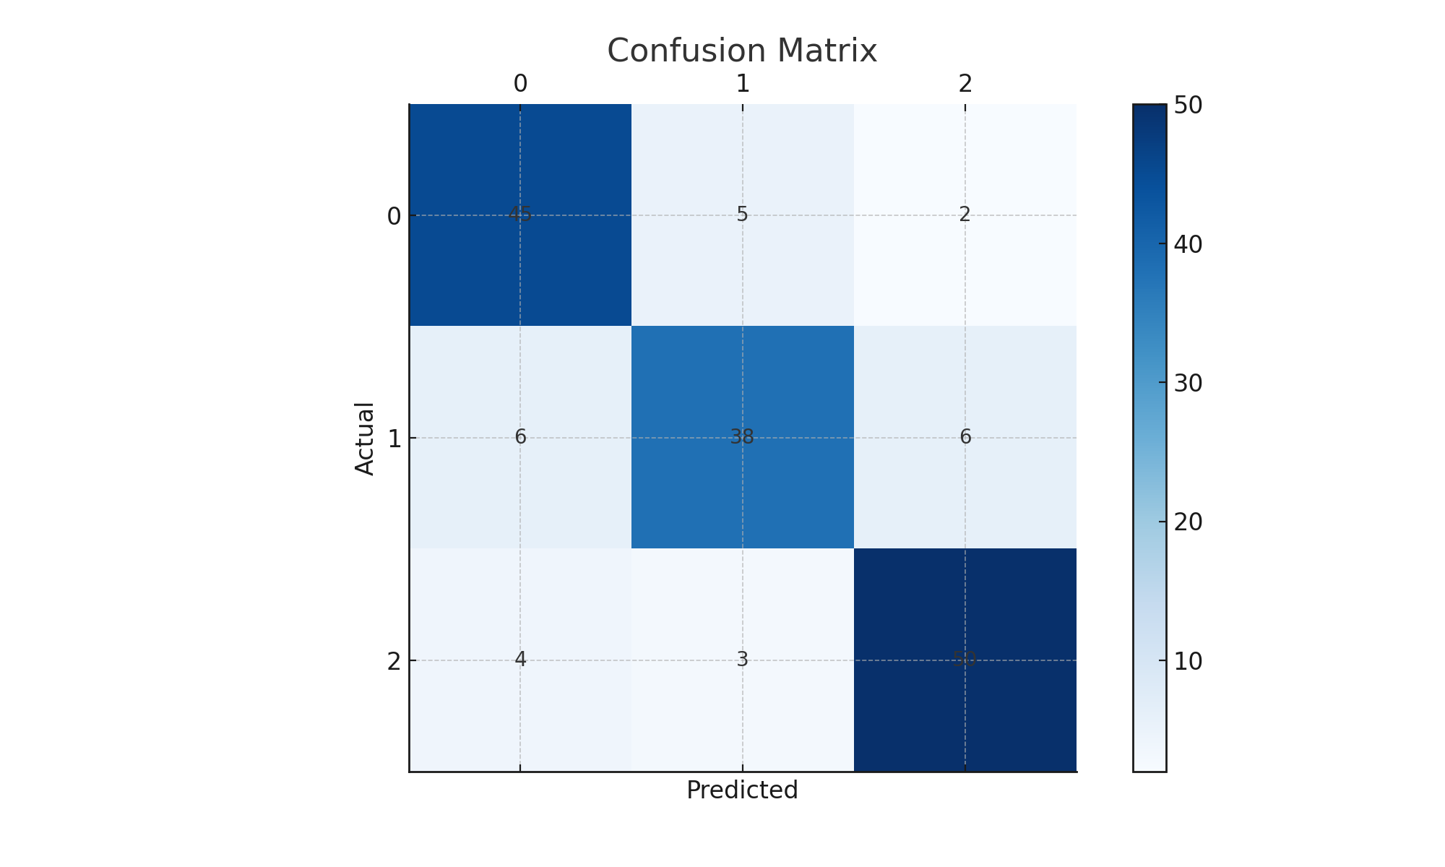

Screenshot - Accuracy Curve:

